 | 7.2.8 Editors - 3D Viewport - Tool Shelf - Curve - Edit Mode
Table of content
Tool Shelf - Curve - Edit Mode 3
Tweak, Select, Transform, 3D Cursor Measure and Annotate tools 3
Curve Stroke Panel 3
Draw 4
Tool Settings 4
Type 4
Method 4
Refit 4
Split 4
Tolerance 4
Detect Corners 5
Corner Angle 5
Taper Start / End 5
Radius Min/Max 5
Use Pressure 5
Depth 5
Cursor 5
Surface 5
Project onto selected 5
Absolute Offset 5
Only First 5
Plane 5
Normal to Surface 5
Tangent to Surface 5
View 5
Curve 2D 6
As Nurbs 6
Last Operator Draw Curve 6
Error 6
Fit Method 6
Corner Angle 6
Cyclic 6
Curve Pen 6
Tool Settings 6
Close Spline 6
Extrude Handle Type 6
Extrude Tools Group 6
Snapping 6
Precision movement 7
Header Values 7
Move without Widget 7
Limit Axis 7
Extrude 7
Header Value 7
Tool Settings 7
Axis Type 8
Drag 8
Active Tool 8
Tweak, Select Box, Circle and Lasso 8
Last operator Extrude Curve and Move 8
Mode 8
Move X , Y , Z 8
Orientation 8
Proportional editing 9
Proportional Falloff 9
Proportional Size 9
Connected 9
Projected(2D) 9
Extrude Cursor 9
Last Operator Add Vertex 9
Location X Y Z 9
Radius 9
Header Value 9
Tool Settings 9
Drag 9
Active Tool 10
Tweak, Select Box, Circle and Lasso 10
Last Operator Transform 10
Values X Y Z W 10
Axis 10
Orientation 10
Mirror Editing 10
Proportional editing 10
Proportional Falloff 10
Proportional Size 10
Connected 10
Projected(2D) 10
Tilt 10
Header Value 11
Tool Settings 11
Drag 11
Active Tool 11
Tweak, Select Box, Circle and Lasso 11
Last Operator Transform 11
Angle 11
Mirror Editing 11
Proportional editing 11
Proportional Falloff 11
Proportional Size 11
Connected 11
Projected(2D) 12
Shear 12
Tool Settings 12
Orientation 12
Drag 12
Active Tool 12
Tweak, Select Box, Circle and Lasso 12
Last Operator Shear 12
Offset 12
Axis 12
Axis Ortho 13
Orientation 13
Mirror Editing 13
Proportional editing 13
Proportional Falloff 13
Proportional Size 13
Connected 13
Projected(2D) 13
Randomize 13
Header Value 13
Tool Settings 13
Uniform 13
Normal 13
Random Seed 14
Drag 14
Active Tool 14
Tweak, Select Box, Circle and Lasso 14
Last Operator Transform 14
Amount 14
Uniform 14
Normal 14
Random Seed 14

Tool Shelf - Curve - Edit Mode
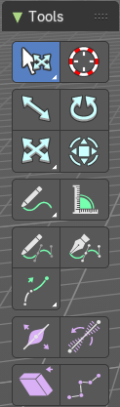
With a curve object in edit mode you will find some tools to edit the curve geometry in the tool shelf.

Tweak, Select, Transform, 3D Cursor Measure and Annotate tools

The tweak, select, transform, 3d cursor, measure and annotate tools at the end of the list are explained in the chapter 7.1.1 Editors - 3D View - Tool Shelf - Object Mode. We won't cover this tools again here.

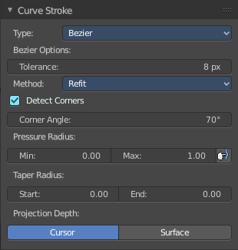
Curve Stroke Panel
The curve stroke panel is covered in the chapter 25.1.1 Editors - Properties Editor - Tools Tab - Edit Mode. We won't cover this tools again here.

Draw
Allows you to draw a curve into the viewport.
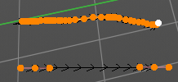

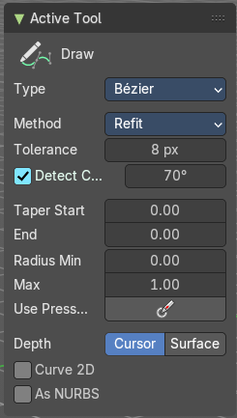
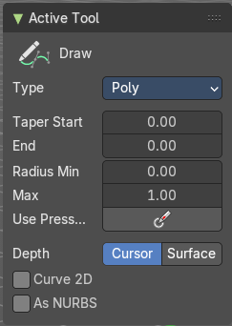
Tool Settings

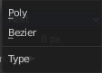
Type
Set the draw method for the curve. Poly draws a simple polygon shape. Bezier creates a Bezier curve type with handlers.
With type Bezier you will get more options.

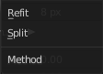
Method
The curve fitting method for a Bezier curve.

Refit
Incrementally refit the curve.

Split
Split the curve until it fits.

Tolerance
Allow deviation for a smoother but less precise line.

Detect Corners
Detect corners and use non aligned angles.

Corner Angle
Corners above this angle are considered as corners.

Taper Start / End
Taper factor for the radius of each curve point.

Radius Min/Max
Minimum or maximum radius when the pressure is applied.

Use Pressure
Use tablet pressure to draw the curve.

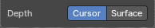
Depth
The method of projecting depth. Cursor or surface.

Cursor
Cursor has no further settings.

Surface

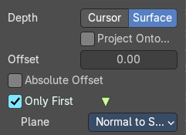
Project onto selected
Projects the strokes only onto selected objects.

Absolute Offset
Apply a fixed offset, and don't scale by the radius.

Only First
Use the start of the stroke for the depth.

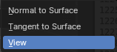
Plane
The plane for the projected strokes.

Normal to Surface
Draw in a plane perpendicular to the surface.

Tangent to Surface
Draw in the surface plane.

View
Draw in a plane that is aligned to the viewport.

Curve 2D
Draw the curve as 2d.

As Nurbs
Draw the curve as nurbs.

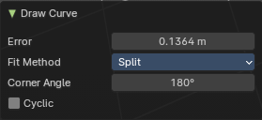
Last Operator Draw Curve

Error
Adjust the error distance threshold in object units

Fit Method
The curve fitting method. Choose between Refit and Split.

Corner Angle
Corners above this angle are considered as corners.

Cyclic
With curve type Bezier the curve gets closed. Has no effect at curve type Poly.

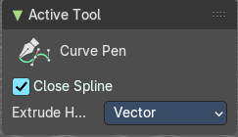
Curve Pen
Extrudes start and end point of the spline to where you click with the mouse.

Tool Settings

Close Spline
Make the spline cyclic.

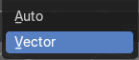
Extrude Handle Type
Type of the extrude handler.

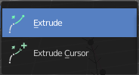
Extrude Tools Group
This tools allows you to extrude out a new curve segment from the current selection

Snapping
Holding down Ctrl activates temporary global snapping.

Precision movement
When you hold down shift, then you will have a much slower but also much preciser movement.

Header Values
When you move your selection then you will see some values in the header, which defines the current position of the extrude point.

Move without Widget
You don't have to use the widget to move the object. You can also click aside of it, and drag the object around. The mouse turns into a move cursor. The standard behavior then is to move in screen space. When you want to move into a specific axis, then press X or Y or Z to limit the movement to this axis.

Limit Axis
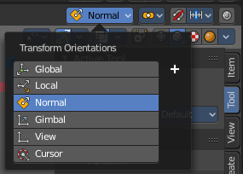
When you want to move along a specific axis, then press X or Y or Z to limit the movement to this axis. You usually start in global orientation. But you can change this in the Orientation settings.
By holding down the mouse button and pressing the X, Y or Z key twice you can toggle this to local. But also to other orientations. This depends in what orientation you start. With normal you can toggle that way between Normal and Global.

Extrude
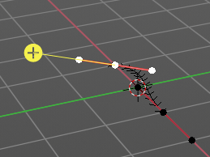
The Extrude tool extrudes the current selection in the direction of the widget.
When you activate the tool, then you will by default see a yellow widget at the selection. Drag it to extrude the selection.

Header Value
When you extrude curve points then you will see a value in the header. It tells you the current target position relative to the initial starting point(s) . This factor always starts with 0.

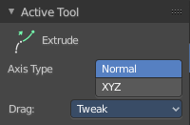
Tool Settings

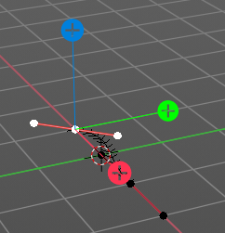
Axis Type
You can choose between the regular axis type. That's the yellow widget with just one handler. It always points in the direction of the middled normals of the selection.
Or you can use the XYZ axis type. That's a handler with three axis. This widget can be aligned with the transform orientation methods.

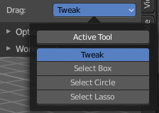
Drag
When you click at the widget of the active tool, then you perform the tool action. Adjust what should happen when you click outside of the widget, in the empty area.

Active Tool
When you click off the widget then the click still does the same than clicking at the widget. It performs the active tool.

Tweak, Select Box, Circle and Lasso
When you choose this options then you will set the off click to the different select methods. Whereas tweak works more than a move tool then. Tweak is the default.

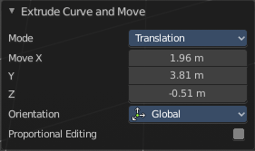
Last operator Extrude Curve and Move

Mode
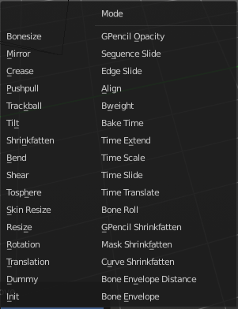
A drop-down box. Choose between different extrude modes.
Default is Translation. Most other methods has no effect.

Move X , Y , Z
The position of the extruded point(s).


Orientation
Adjust the orientation of the extrusion. It usually starts with Normal.

Proportional editing
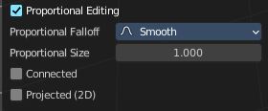
Enables proportional editing. Activating proportional editing reveals further settings.

Proportional Falloff
Adjust the falloff methods.

Proportional Size
See and adjust the falloff radius.

Connected
The proportional falloff gets calculated for connected parts only.

Projected(2D)
The proportional falloff gets calculated in the screen space. Depth doesn't play a role. When it's in the radius, then it gets calculated.

Extrude Cursor
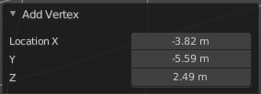
Extrudes the control points to where you click.

Last Operator Add Vertex

Location X Y Z
The location of the new created control point(s).

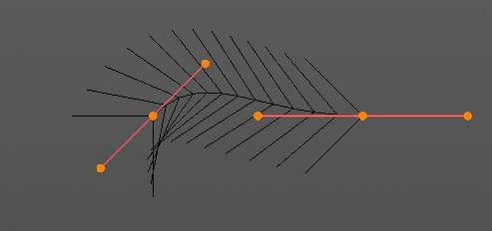
Radius
Bezier curves have a radius. This is displayed by the black lines that points away from the curve. The radius tool allows you to resize this radius.

Header Value
When you resize the curve radius then you will see a value in the header. It tells you the current scale factor. This factor always starts with 1.

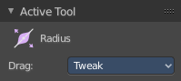
Tool Settings

Drag
When you click at the widget of the active tool, then you perform the tool action. Adjust what should happen when you click outside of the widget, in the empty area.

Active Tool
When you click off the widget then the click still does the same than clicking at the widget. It performs the active tool.

Tweak, Select Box, Circle and Lasso
When you choose this options then you will set the off click to the different select methods. Whereas tweak works more than a move tool then. Tweak is the default.

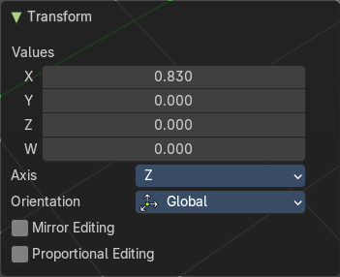
Last Operator Transform

Values X Y Z W
The axis to increase the radius. Just X has an effect with the curve radius.

Axis
The axis to use. This has no effect with a curve object.

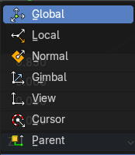
Orientation
Adjust the orientation of the extrusion. It usually starts with Normal.

Mirror Editing
Enable mirror editing.

Proportional editing
Enables proportional editing. Activating proportional editing reveals further settings.

Proportional Falloff
Adjust the falloff methods.

Proportional Size
See and adjust the falloff radius.

Connected
The proportional falloff gets calculated for connected parts only.

Projected(2D)
The proportional falloff gets calculated in the screen space. Depth doesn't play a role. When it's in the radius, then it gets calculated.

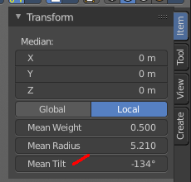
Tilt
With this tool you can tilt the curve. It is the mean tilt value in the Transform panel of the Sidebar.

Header Value
When you rotate the curve with the tilt tool, then you will see a value in the header. It tells you the current rotation relative to the starting rotation. This value always starts with 0.

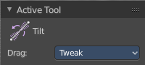
Tool Settings

Drag
When you click at the widget of the active tool, then you perform the tool action. Adjust what should happen when you click outside of the widget, in the empty area.

Active Tool
When you click off the widget then the click still does the same than clicking at the widget. It performs the active tool.

Tweak, Select Box, Circle and Lasso
When you choose this options then you will set the off click to the different select methods. Whereas tweak works more than a move tool then. Tweak is the default.

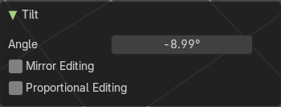
Last Operator Transform

Angle
This value tells you the current rotation relative to the starting rotation. This value always starts with 0.

Mirror Editing
Enable mirror editing.

Proportional editing
Enables proportional editing. Activating proportional editing reveals further settings.

Proportional Falloff
Adjust the falloff methods.

Proportional Size
See and adjust the falloff radius.

Connected
The proportional falloff gets calculated for connected parts only.

Projected(2D)
The proportional falloff gets calculated in the screen space. Depth doesn't play a role. When it's in the radius, then it gets calculated.

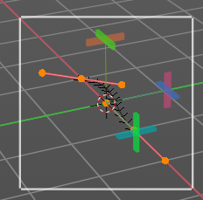
Shear
The shear tool allows you to shear the selected geometry. When you activate the tool, then a widget appears that allows you to pull in the desired direction.

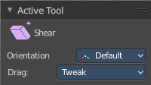
Tool Settings

Orientation
Choose the orientation for the shear action.

Drag
When you click at the widget of the active tool, then you perform the tool action. Adjust what should happen when you click outside of the widget, in the empty area.

Active Tool
When you click off the widget then the click still does the same than clicking at the widget. It performs the active tool.

Tweak, Select Box, Circle and Lasso
When you choose this options then you will set the off click to the different select methods. Whereas tweak works more than a move tool then. Tweak is the default.

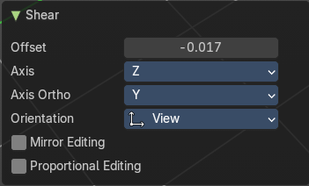
Last Operator Shear

Offset
Adjust an offset.

Axis
Defines one axis of the imaginary shear axis plane.

Axis Ortho
Defines the other axis of the imaginary shear axis plane.

Orientation
Choose the orientation for the shear action.

Mirror Editing
Enable mirror editing.

Proportional editing
Enables proportional editing. Activating proportional editing reveals further settings.

Proportional Falloff
Adjust the falloff methods.

Proportional Size
See and adjust the falloff radius.

Connected
The proportional falloff gets calculated for connected parts only.

Projected(2D)
The proportional falloff gets calculated in the screen space. Depth doesn't play a role. When it's in the radius, then it gets calculated.

Randomize
Randomize the position of the selected polygon or control points.

Header Value
When you randomize the points, then you will see a value in the header. It tells you the current randomization amount. This value always starts with 0.

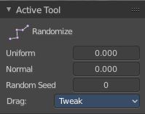
Tool Settings

Uniform
With a value of 0 the randomization happens uniformly. The higher the value the more uniform the randomization affects the selected points.

Normal
Align the offset direction to normals. This value has no effect.

Random Seed
A random seed value.

Drag
When you click at the widget of the active tool, then you perform the tool action. Adjust what should happen when you click outside of the widget, in the empty area.

Active Tool
When you click off the widget then the click still does the same than clicking at the widget. It performs the active tool.

Tweak, Select Box, Circle and Lasso
When you choose this options then you will set the off click to the different select methods. Whereas tweak works more than a move tool then. Tweak is the default.

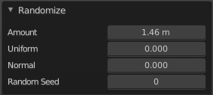
Last Operator Transform

Amount
The randomization amount.

Uniform
With a value of 0 the randomization happens uniformly. The higher the value the more uniform the randomization affects the selected points.

Normal
Align the offset direction to normals. This value has no effect.

Random Seed
A random seed value.

